

**OTS Bench Maintenance Kit Detailed Step-by-Step Guide**

**Part number: 900486-000**

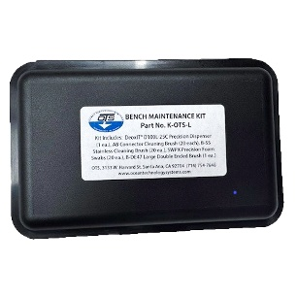

1. Preparation:

* Unplug and Disconnect: Disconnect the device or equipment where you want to clean the connectors.
* Safety: Highly recommend using gloves.
* Inspect**:** 
  + For oxidation and/or corrosion
  + Brush away dirt, sand, dried salt, and debris
  + LP Air to blow out female connectors (if available)

2. Cleaning Brushes

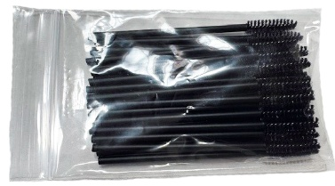 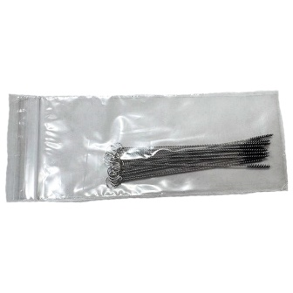 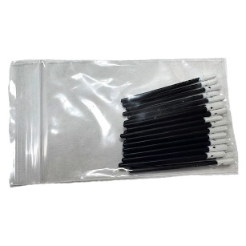

* Match cleaning brushes to connector sizes.
* If debris is detected in the female connector, use LP Air to remove it before inserting cleaning brushes.

3. Applying Cleaning Solution:

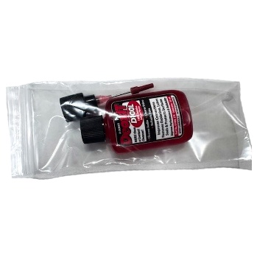

* Apply a light amount of the solution to the connector surfaces.
* Use the applicator to apply a small amount of solution to the contact points.
* Use a precision foam swab, apply 2 drops to the tip, then insert the tip into the female connector and turn.
* Ensure that the solution is applied to the metal surfaces of the connectors where the connection occurs.

4. Allowing Solution to Work:

* + Let it Sit: Allow the solution to sit on the contact surfaces for a few minutes to allow it to break down any oxidation or residue.
* Heavy Oxidation:
  + For heavily oxidized connectors, you may need to leave the solution on for longer periods of time.

4. Cleaning and Removal:

* Wipe or Swab: Use a clean cloth, cotton swab, or brush to wipe away any loosened debris or residue.
* Repeat as Needed: If necessary, repeat the process of applying the solution, letting it sit, and cleaning until the connectors are clean and free of residue.

5. Final Steps:

* Reconnect: Once the connectors are clean and dry, reattach the device or equipment.
* Test: Plug in and test the device to ensure that the connections are working correctly

Important Notes:

* Don't Over-Apply: Avoid applying too much solution, as it can attract dirt and debris.
* Test First: If unsure about the application on a specific device, test it on a small, inconspicuous area first.
* Consult Solution Instructions: Always refer to the specific DeoxIT product instructions for the best application methods.